**INSTRUCTIONS**

1. When users order a package online, he/she navigates to the SureLock web page and clicks “Generate Code” to receive a 6-digit numeric code. *This code would then be placed under a package’s “Special Delivery Instructions”.*

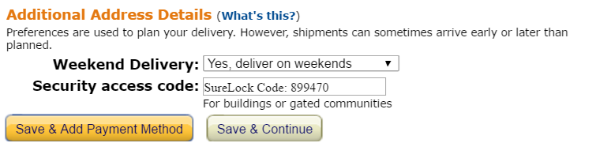

1. 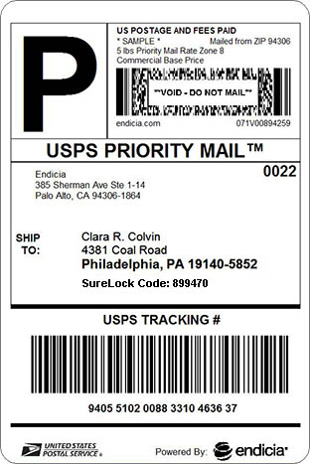This code, printed onto the shipping label, can be used once to enter the building. Enter the code on the keypad, followed by the * button to open the door. Use the # button to reset the code input. *This step allows the delivery person to enter the building.*
2. To store a package, place it into the locker and enter the apartment number of the intended recipient, followed by the * button. *This step locks the package into the locker, and notifies the resident by text message.*
3. Check the phone for the newly generated 5-digit numeric code. Enter this code into the keypad followed by the * button. *This step will unlock the locker and finish the package delivery and retrieval process.*